POWER ELECTRONICS

THEORY

1. Solid State Relay:
2. Definition:

* An electronic switching device made of semiconductors that switch (ON or OFF) when an external voltage is applied across its control terminals

1. Operation:

* When a low voltage is applied to the input control terminals, it activates the optocoupler which switch the load circuit. The optocoupler has no physical connection & it isolates the low voltage circuit from the high voltage circuit.

1. Topology:

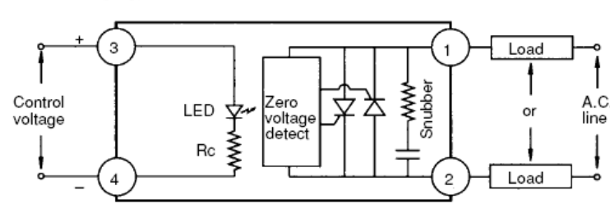

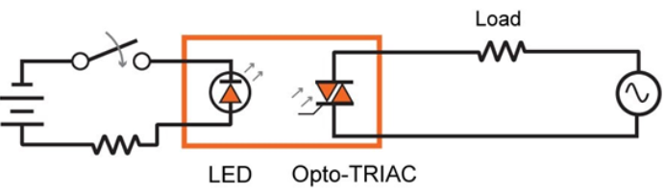

1. Advantages:

* Fast switching speed
* Have high endurance limit and operational lifetime
* Have no physical contacts to wear out
* Have low current control but can control high voltage
* Do not create any arch or electrical noise

1. Disadvantages:

* Unable to withstand a large momentary overload
* Dissipate too much heat
* More sensitive to voltage transients

1. Application:

* Heating control (Textile, Drying, Thermoforming, HVAC), Motor Starting (Pumps, Conveyors, Lifts), Lighting (Airport runways, Streets and roadways lighting)

1. Soft Starter:
2. Definition:

* A soft starter is a solid – state system or device that protects AC electric motors from damage caused by sudden influxes of power through the controlling applied voltage to 3 phase motor

1. Topology:

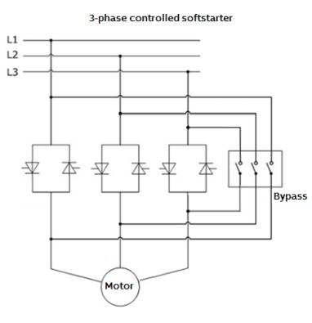

1. Operattion:

* Start: Firing angle is sent to thyristors so that only the last part of each half period of sinusoidal voltage wave is passed through it. After the start, firing signal send to earlier and earlier to allow bigger and bigger part of voltage wave to pass through thyristor
* Stop: The full voltage is allowed to pass through the thyristor, the firing signal is sent later and later allowing less and less of the voltage to pass through until the end voltage is reached. Then no more voltage is applied and the motor stops

1. Advantages:

* Reduce energy use
* Smooth Startup
* Acceleration & Deceleration Control
* No Power Surges

1. Disadvantages:

* No speed regulation
* Heat dissipation
* Reduce starting torque

1. Application:

* Fans, Conveyer Belts, Motors Using Belt & Pulleys, Water or Liquid Pump

1. High Frequency Switching:
2. High frequency switching is preferred in modern power converter as:

* Reduce size of associated components such as the inductors, transformers, resistors and capacitors. This leads to smaller size of converter and lower cost
* Faster transient load response time
* The higher the frequency switching is, the lower value output ripple current can get

1. How to reduce the switching power loss in high frequency converter:

* Soft switching
* Zero voltage switching
* Zero current switching

1. SVC Systems:
2. Definition:

* SVC systems is one of the reactive power compensation and voltage regulation which consist of static, or semiconductors, switching elements
* Topology:

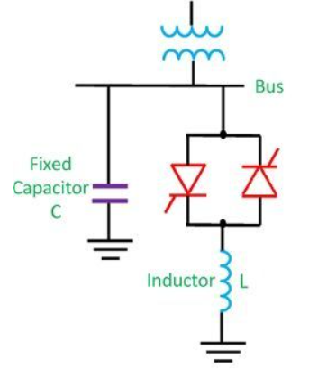

1. Operation:

* The firing angle of the thyristor controls the voltage across the inductor and thus the current flowing through the inductor. In this way, the reactive power draw by the inductor can be controlled.

1. Advantage:

* Improve the load power factor
* Increase the power transmission capability of the transmission lines
* Improve the transient stability of the system
* Control the steady state and temporary overvoltages

1. Application:

* Transmission and Distribution Systems
* Mining industry
* Cement industry
* Oil & gas industry

1. Soft Switching:
2. Definition:

* Soft switching means that one or more power switches in a dc-dc converter have either the turn-on of turn-off switching loss eliminated.

1. Operation:

* Switching occur under favorable conditions – device voltage of current is zero

1. Advantages:

* Reduced switching loss, switch stress
* Possibly low EMI
* Easier thermal management
* Increase in efficiency

1. Disadvantages:

* The architecture only works in non-isolated power converters when input voltage and output loads stay within a narrow range.